**SYSTEM GENERATED E-R DIAGRAM**

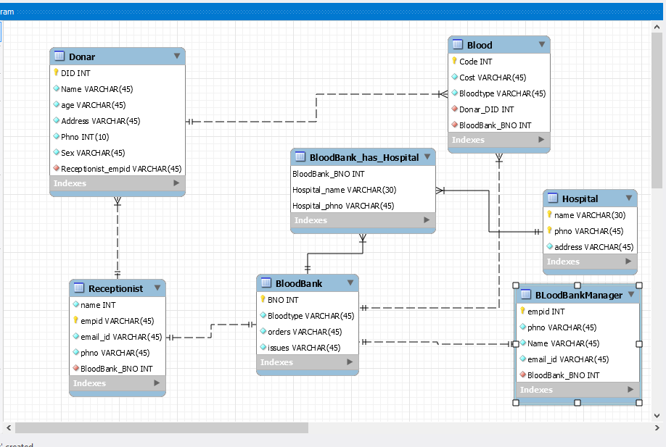

**CREATE STATEMENTS**

create database blood_bank;

1.CREATE TABLE IF NOT EXISTS `blood_bank`.`BloodBank` (

`BNO` INT NOT NULL,

`Bloodtype` VARCHAR(45) NOT NULL,

`orders` VARCHAR(45) NOT NULL,

`issues` VARCHAR(45) NOT NULL,

PRIMARY KEY (`BNO`));

2.CREATE TABLE IF NOT EXISTS `blood_bank`.`Receptionist` (

`empid` INT NOT NULL,

`name` VARCHAR(45) NOT NULL,

`email_id` VARCHAR(45) NOT NULL,

`phno` VARCHAR(45) NOT NULL,

`BloodBank_BNO` INT NOT NULL,

PRIMARY KEY (`empid`),

FOREIGN KEY (`BloodBank_BNO`)

REFERENCES `blood_bank`.`BloodBank` (`BNO`)

ON DELETE NO ACTION

ON UPDATE NO ACTION);

3.CREATE TABLE IF NOT EXISTS `blood_bank`.`Donar` (

`DID` INT NOT NULL,

`Name` VARCHAR(45) NOT NULL,

`age` VARCHAR(45) NOT NULL,

`Address` VARCHAR(45) NOT NULL,

`Phno` INT(10) NOT NULL,

`Sex` VARCHAR(45) NOT NULL,

`Receptionist_empid` int NOT NULL,

PRIMARY KEY (`DID`),

FOREIGN KEY (`Receptionist_empid`)

REFERENCES `blood_bank`.`Receptionist` (`empid`)

ON DELETE NO ACTION

ON UPDATE NO ACTION);

4.CREATE TABLE IF NOT EXISTS `blood_bank`.`Blood` (

`Code` INT NOT NULL,

`Cost` VARCHAR(45) NOT NULL,

`Bloodtype` VARCHAR(45) NOT NULL,

`Donar_DID` INT NOT NULL,

`BloodBank_BNO` INT NOT NULL,

PRIMARY KEY (`Code`),

FOREIGN KEY (`Donar_DID`)

REFERENCES `blood_bank`.`Donar` (`DID`)

ON DELETE NO ACTION

ON UPDATE NO ACTION,

FOREIGN KEY (`BloodBank_BNO`)

REFERENCES `blood_bank`.`BloodBank` (`BNO`)

ON DELETE NO ACTION

ON UPDATE NO ACTION);

5.CREATE TABLE IF NOT EXISTS `blood_bank`.`BLoodBankManager` (

`empid` INT NOT NULL,

`phno` VARCHAR(45) NOT NULL,

`Name` VARCHAR(45) NOT NULL,

`email_id` VARCHAR(45) NOT NULL,

`BloodBank_BNO` INT NOT NULL,

PRIMARY KEY (`empid`),

FOREIGN KEY (`BloodBank_BNO`)

REFERENCES `blood_bank`.`BloodBank` (`BNO`)

ON DELETE NO ACTION

ON UPDATE NO ACTION);

6.CREATE TABLE IF NOT EXISTS `blood_bank`.`Hospital` (

`name` VARCHAR(30) NOT NULL,

`phno` VARCHAR(45) NOT NULL,

`address` VARCHAR(45) NOT NULL,

PRIMARY KEY (`name`, `phno`));

7.CREATE TABLE IF NOT EXISTS `blood_bank`.`BloodBank_has_Hospital` (

`BloodBank_BNO` INT NOT NULL,

`Hospital_name` VARCHAR(30) NOT NULL,

`Hospital_phno` VARCHAR(45) NOT NULL,

PRIMARY KEY (`BloodBank_BNO`, `Hospital_name`, `Hospital_phno`),

FOREIGN KEY (`BloodBank_BNO`)

REFERENCES `blood_bank`.`BloodBank` (`BNO`)

ON DELETE NO ACTION

ON UPDATE NO ACTION,

FOREIGN KEY (`Hospital_name` , `Hospital_phno`)

REFERENCES `blood_bank`.`Hospital` (`name` , `phno`)

ON DELETE NO ACTION

ON UPDATE NO ACTION);